Wandering in the Woods Game: Agile Project Documentation

Rachael Morrison, Benjamin Ayirifa, Shivasai Priyatham Kota, and Siva Prasad Polisetty

College of Aviation, Science, and Technology, Lewis University

FA22-CPSC-60500-004 Software Engineering

Dr. Fadi I. Wedyan

December 14, 2022

***ALL INFORMATION IS CURRENTLY FROM TEMPLATE FOR A DIFFERENT PROGRAM**

Table of Contents

1.0 Introduction 2

1.1 Purpose 2

1.2 Description 2

2.0 Process Model

3.0 Use Cases

3.1 Use Case 1:

3.2 Use Case 2:

3.3 Use Case 3:

3.4 Use Case 4:

3.5 Use Case 5:

3.6 Use case 6:

4.0 UML Model

4.1 Use Case Diagram

4.2 Class Diagram

4.3 Activity Diagram

5.0 Personas

6.0 UI Mock-up

7.0 User Guide

7.1 Teachers

7.2 Students

# Introduction

## Purpose

The purpose of the program is intended to educate students about computation and mathematics. This is fun game design to simulate the performance of students in computer knowledge.

## Description

The game application was designed to simulate difficult based on the level of the student. This program was designed for students in basic schools and hence has being partitioned into 3 levels. The level in this program includes:

1. K2 level: - In this level, 2 players are strictly allowed by the program. The player has no option to select more players. The program is reset anytime the two players get in to the same grid. Music will play when two players bump into each other.
2. Grade 3-5 Level: - This is the intermediate level. Four players are display on the screen when the user starts the program. The program gets restarted anytime any of the two players bump into each other. When two players get into the same grid, then performance is climaxed; celebration music will play and the program will continue until all players are found in the same grid. The can set the size of the grid and number of players. The minimum number of players is 2 and the maximum number of players that can be selected from this level is 4.
3. Grade 6-8 Level: This is the most difficult level; it is the most flexible level. The user has the chances to choose the number of players and grid size. The user has all the functionalities for the levels discussed above. There is a maximum of eight players allowed by the program.

The game application is compatible with windows and MAC OS operation systems. The program is to install and easy to use. User can copy it from one computer to another by using flash drives and other portable system. Users have to double on the program to start and can close the program by clicking on the exit button.

# Process Model

The software development team will use the evolutionary process model as show in Figure 1. The model the team selected is based on the desire to allow for rapid prototyping and iteration of design. The model is based on agile and spiral model principals in order to encapsulate feedback and risk management in to the decisions making for continuous evolution of the game.

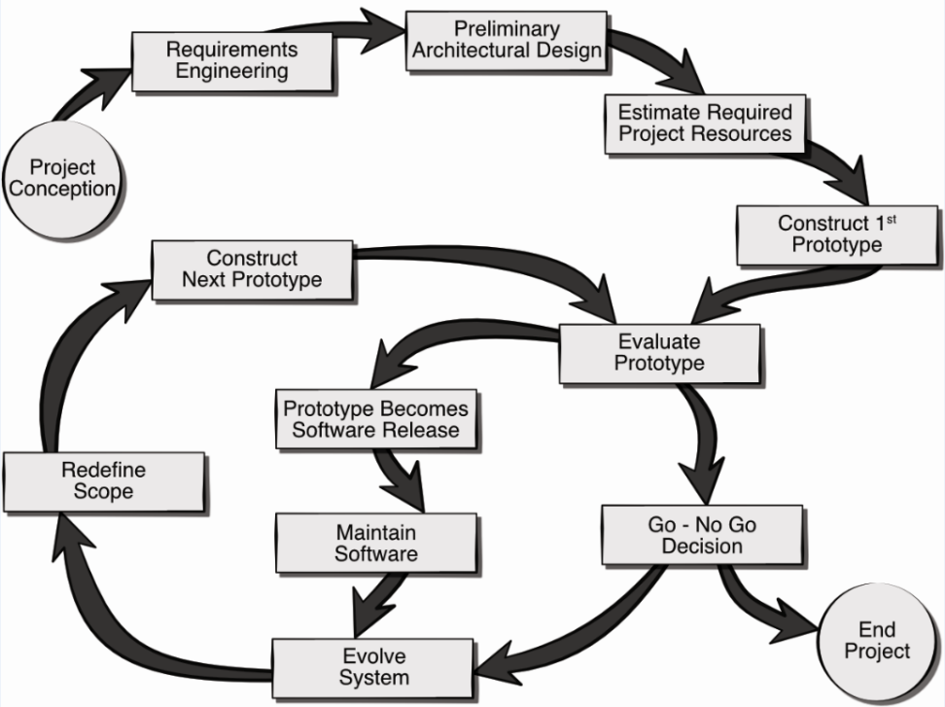

*Figure SEQ Figure \* ARABIC 1. The AR Room Designer evolutionary process model.*

# Use Cases

The following uses cases were defined by the team as the core system requirements for the delivery of working prototype. Note, this baseline functionality can be easily extended through the inclusion of more use cases as the project progresses. Each use case lists the name of the use case, primary actors, preconditions, description, and acceptance criteria.

## Use Case 1:

**Primary Actor:** K2 Student/User

**Preconditions:** Program must be compatible with user’s operating system

**Description:** Student double clicks on the application icon

Application starts

Application ask student to select level, then the games starts

**Acceptance Criteria:** users must be able to start the program on their own with little with little or no help

## Use Case 2:

**Primary Actor:** Grade 3-5 Student

**Preconditions:** Program must be installed on a compatible operating system

**Description:** Students double click on the program to start the program. The program prompts the user to select the grid size and number of players.

Game then starts using the requirements of the user selections

**Acceptance Criteria:** Grade 3-5 students must be able to modify the number of players and size of the grid.

## Use Case 3:

**Primary Actor:** Grade 6-8 Student

**Preconditions:** Program must be compatible with OS on the user computer

**Description:** User double clicks on the game icon to that the program.

Program prompts user to select level based on the grade

After selection of the 6th-8th grade, application grants permission to user to modify grid size, number of players and run experiments

**Acceptance Criteria:** Student should be able to monitor performance at anytime

## Use Case 4:

**Primary Actor:** Student

**Preconditions:** Program must be compatible with OS on the user computer

**Description:** The student starts decides to play the game by double clicking on the desktop icon for the program.

The student decides not to place once the on main menu of the game screen.

Student clicks on the exit button or the Microsoft close button or the exit button.

Program ask user if user wants to close the game, user confirms and program terminates

**Acceptance Criteria:** The program should be able to close at any time the user changes his/her mind not to play the game.

# UML Model

## Use Case Diagram

In the analysis of the software application, we determined that the student to be the primary actor in all the cases discussed above. The system is made up of modules and classes. The game user interacts with the software application in this pattern.

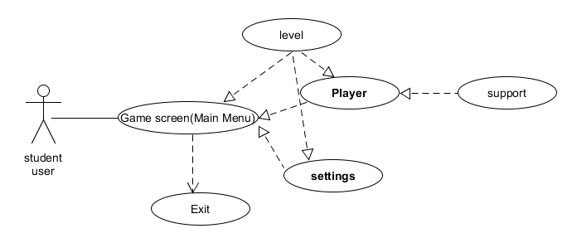

## Class Diagram

The class diagram for the core system of the Wandering in the Woods game is depicted in Figure 4. The classes in the diagram are described below the figure.

*** Class diagram ***

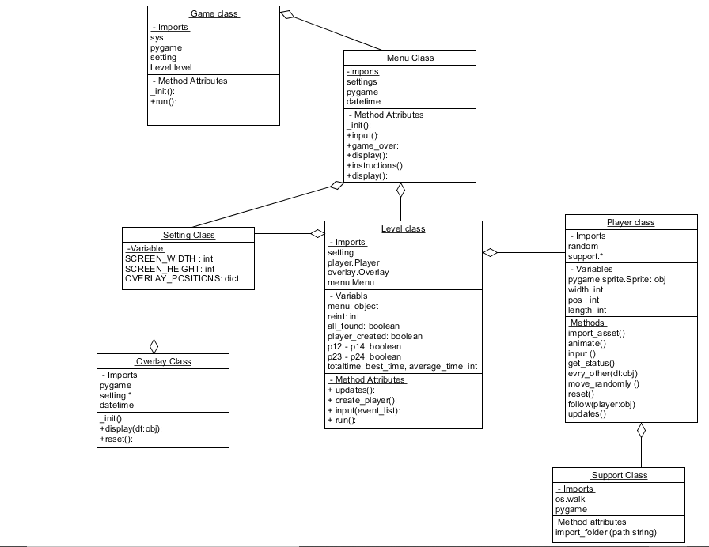

## Activity Diagram

The activity diagram shown in Figure 5 presents a more detailed description of the high-level behavior of the Wandering in the Woods game.

*** Figure 5 goes here ***

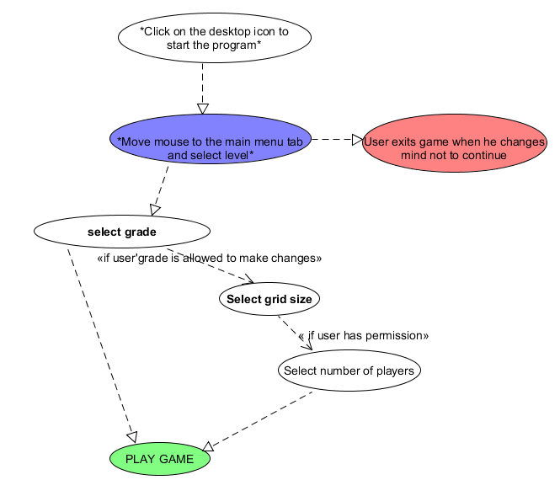

# Personas

Figure 6 and figure 7 show two representative samples of a personas for the Wandering in the Woods game.

*** Figure 6 TEACHER ***

*** Figure 7 STUDENT ***

# UI Mock-up

The user interface mock-up for the Wandering in the Woods game is presented in Figure 8.

*** Figure 8 ***

# User Guide

## Teachers

## Students